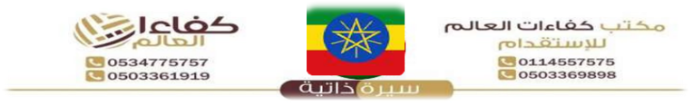

{%facePhoto} |  |  | Reference Number |  |  | {%refNumber}
 |  |  | Full Name |  |  | {%fullName} |  | الاسم
 |  |  | Religion |  |  | {%religion} |  | الديانة
 |  |  | Position Desired |  |  | {%position} |  | الوظيفة
 |  |  | Salary |  |  | {%salary} |  | الراتب
 |  |  | Age |  |  | {%age} |  | العمر
 |  |  | Sex |  |  | {%gender} |  | الجنس
Personal Information |  |  |  | معلومات شخصيه |  | Passport Information |  | معلومات الجواز
Nationality |  | {%nationality} |  | الجنسية |  | Number | {%passportNumber}
Date of Birth |  | {%dob} |  | تاريخ الميلاد |  | Issue Date | {%issueDate} | الإصدار
Address |  | {%address} |  | العنوان |  | Expiry Date | {%expiryDate} | الانتهاء
Marital Status |  | {%maritalStatus} |  | الحالة الاجتماعية |  | Issue place | {%issuePlace} | الاصدار
No. of Children |  | {%numberOfChildren} |  | عدد الأطفال |  | Next of Kin name | {%emergencyName} | خص
Height/Weight |  | {%height} / {%weight} |  | الوزن والطول |  | Next of Kin number | {%emergencyPhone} | رتب
Education Qualifications |  | {%educationLevel} |  | المستوى التعليمي |  | {%fullBodyPhoto}
Tel. Number |  | {%phone} |  | رقم التواصل
Overseas Experience |  |  | خبرات سابقه
Country |  | Period | Position
{%expCountry} |  | {%expPeriod} | {%expPosition}
Skills |  |  | المهارات
Cooking | {%skillCook} | الطبخ | Baby Sitting | {%skillBaby} | التعامل
Washing | {%skillWash} | الغسيل | Sewing | {%skillSew} | الخياطة
Cleaning | {%skillClean} | التنظيف | Driving | {%skillDrive} | سائق
Languages |  |  | اللغات
 | English  الانجليزية |  | Arabic  العربية
Good | {%english} |  | {%arabic}
Fluent | NO |  | NO
REMARKS: SHE IS HARDWORKING, NEAT, ORGANISED, SMART, DISCIPLINED, CARING, HAS A GOOD ATTITUDE, SPEAKS GOOD ENGLISH AND LOVES TAKING CARE OF CHILDREN.

Scan for Video / QR Code
{%qrCode}

{%passport image}

